PMAS Arid – UIIT



Web Technologies CS – 566

Project Title:

**Medicare (Medicine Delivery App)**

**BSSE – 4**

(Morning)

Submitted by:

**Kashf Jahangir 19 – ARID – 1193**

**Farwa Yassal 19 – ARID – 1183**

**Mahnoor Amjad 19 – ARID – 1995**

Submitted to: Dr. Shakeel Ahmed

Submitted on: 24.04.21

**GitHub link:** <https://github.com/kashf79923/Web-Technology-Project.git>

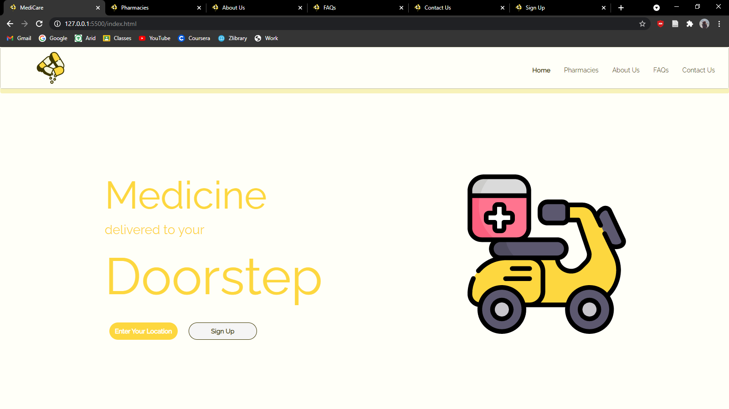

Homepage

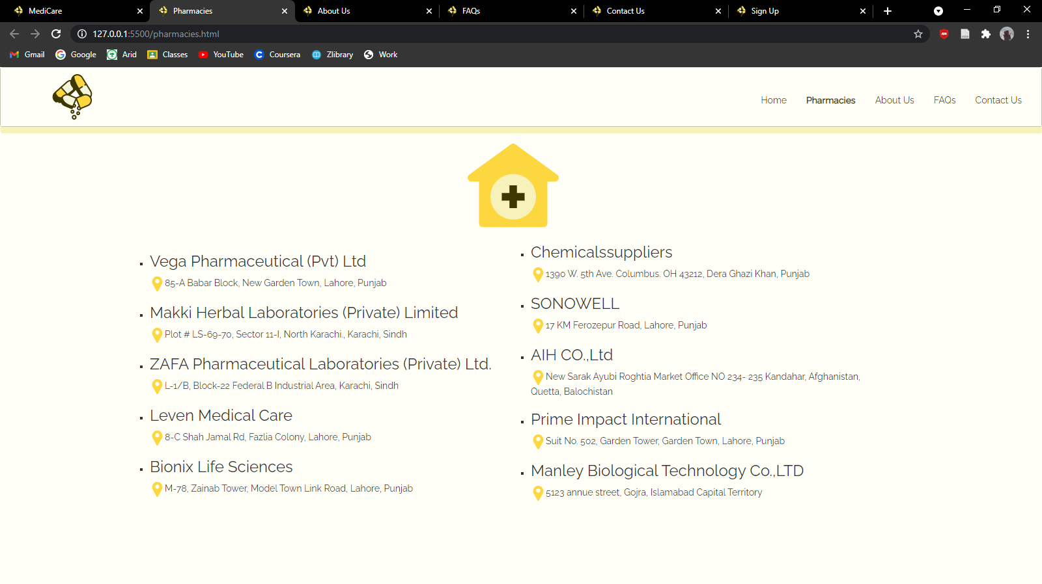

Pharmacies

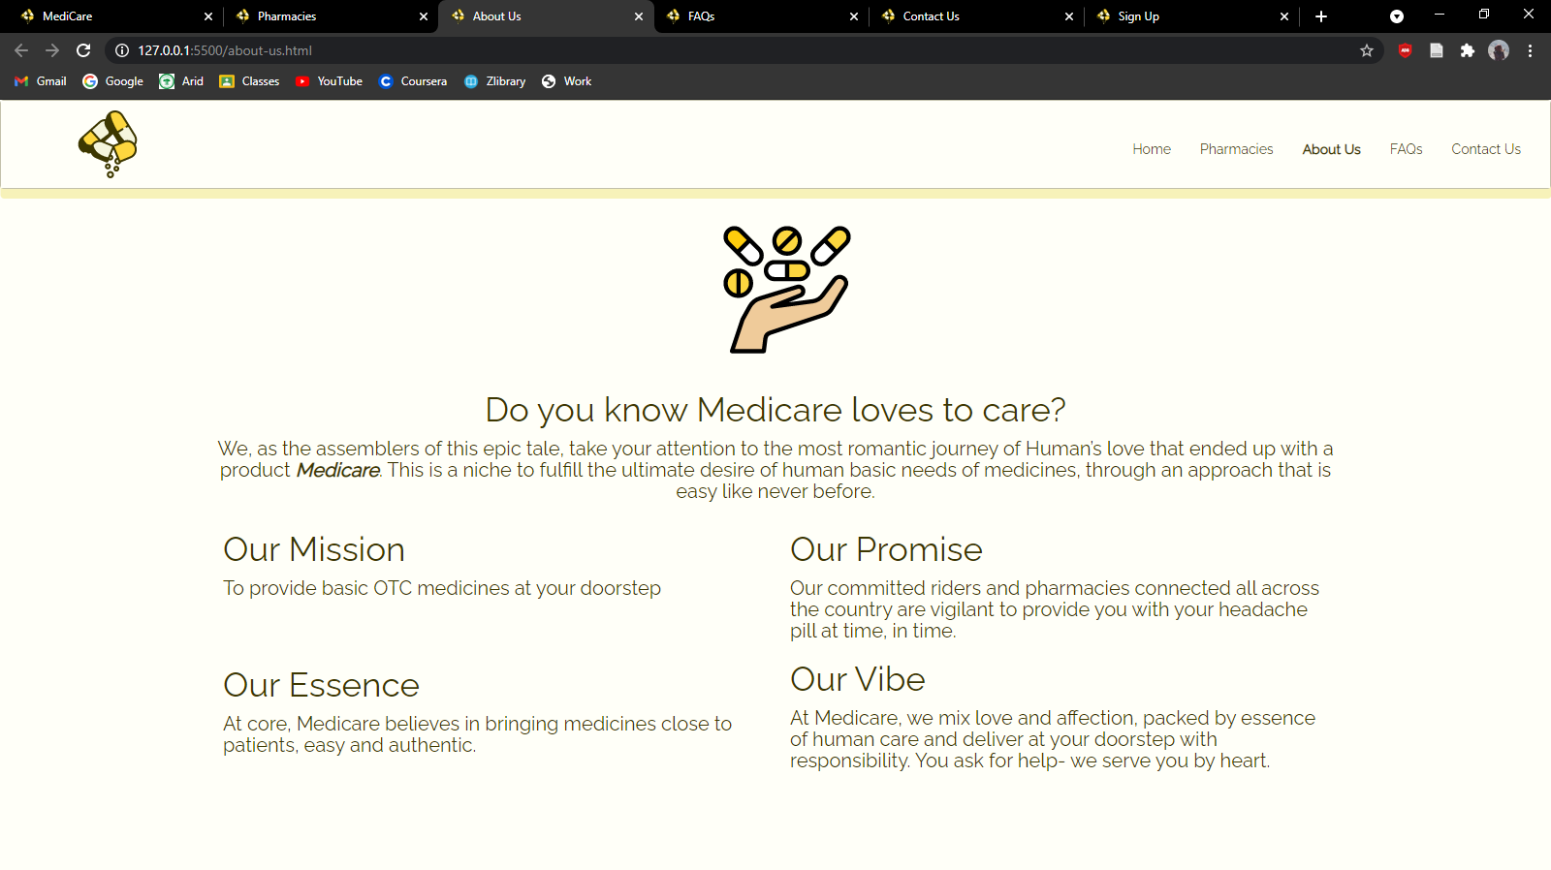

About Us

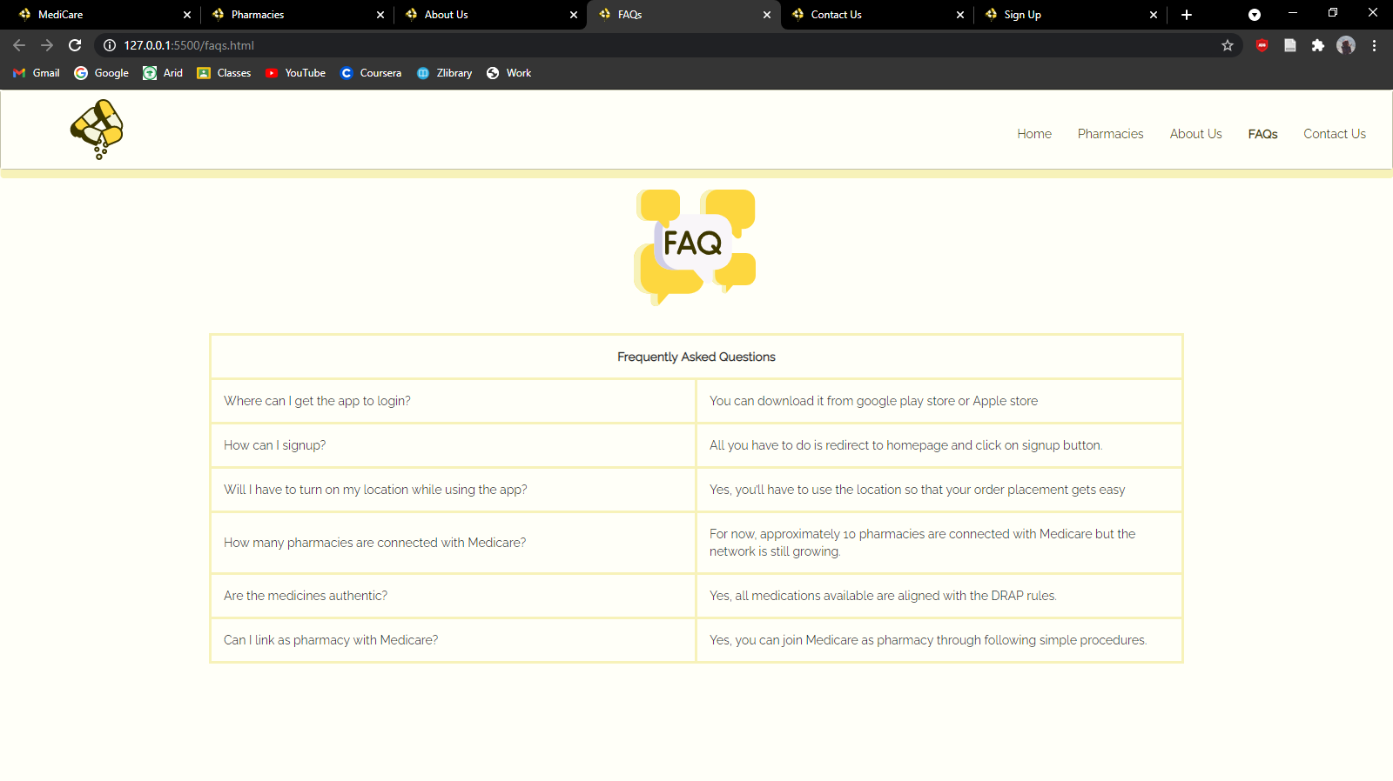

FAQs

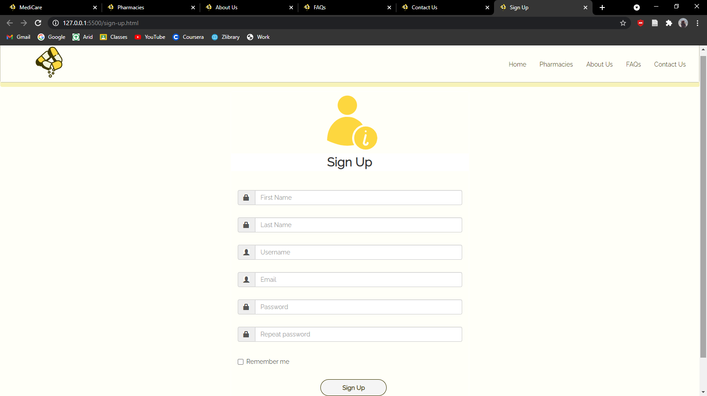

Sign Up

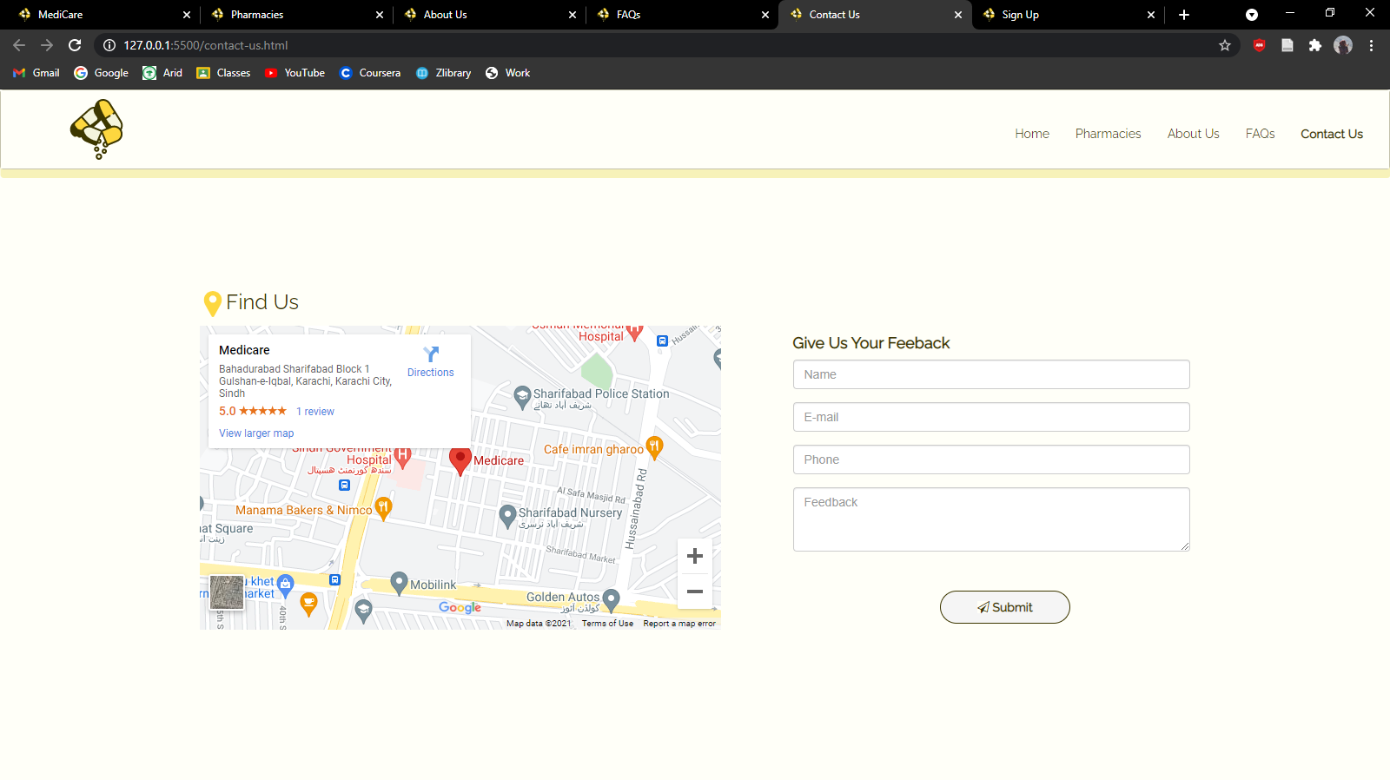

Contact Us

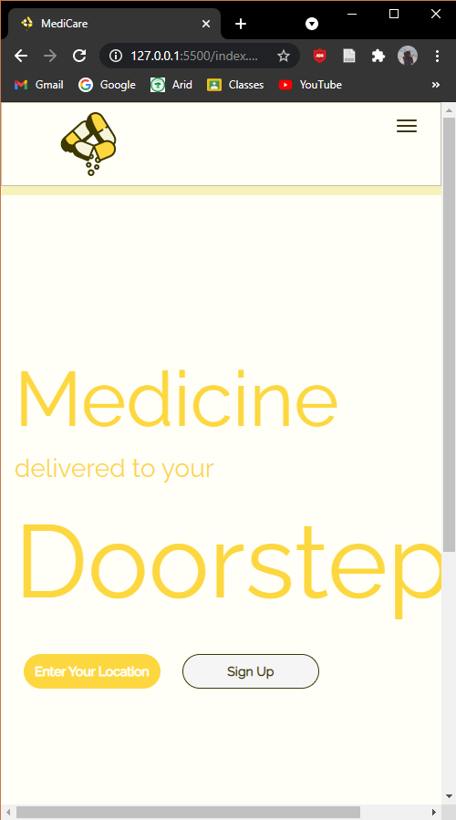

Hamburger Menu (Closed)

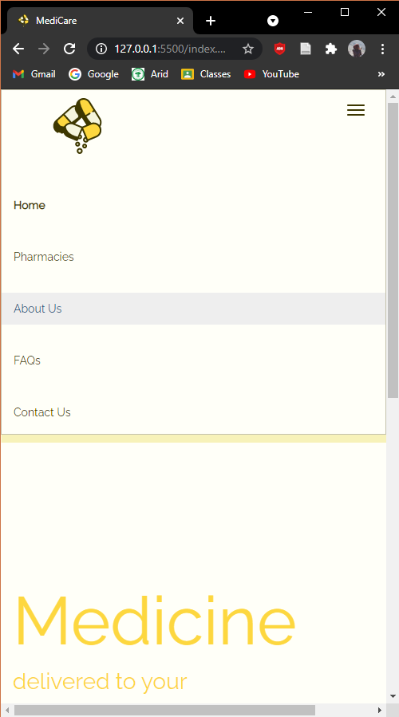

Hamburger Menu (Opened)